Use Case Diagram – Wayne Thomas – CIT 360

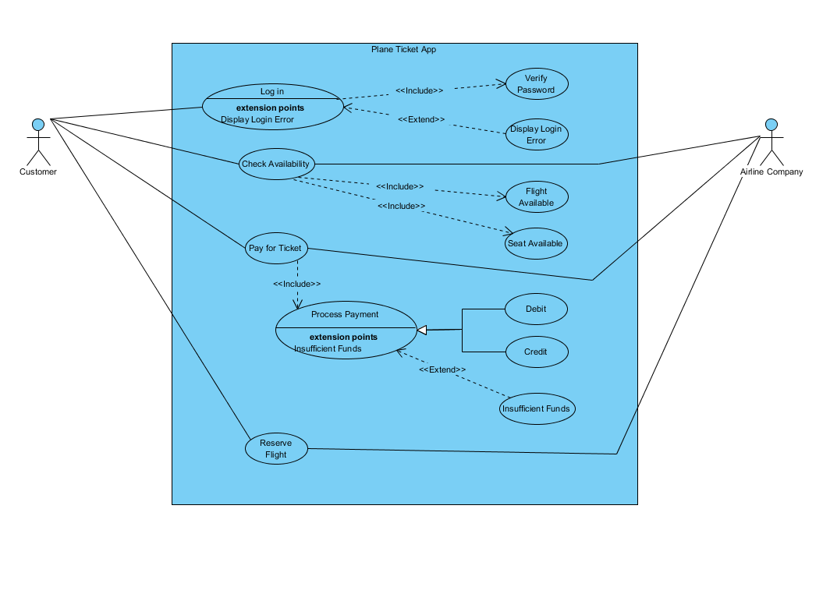

This is a use case diagram for a Plane Ticket App for a website or mobile device. Once the customer (Primary Actor) reaches the website or opens the application, they will have the opportunity to login to their account. In this case, the Log In use case requires the interaction of the Verify Password Use case each time it is executed. Therefore, the relationship between the two use cases is an <<Include>> relationship. In the case of the Display Login Error use case, it will not execute unless it meets certain criterial, making it an <<Extend>> relationship. In this example, when the user enters in the wrong password or user information, the Display Login Error will execute.

Once the customer is logged into the site/app, they can now look to see if a flight is available. This is where our customer reaches the Check Availability use case. This will also be the time when interaction with our Airline Company (Secondary Actor) comes into play. The Check Availability use case will always check to see if there are Flights Available as well as Seats Available during its process. This creates another <<Include>> relationship. The Airline Company keeps track of that information and provides it to the Customer. In theory, we could add an <<Extend>> use case to cover no flight or seats available, but I am choosing to keep it simple at this point.

The next step will be the Pay for Ticket use case. Here we have an <<Include>> relationship between the Pay for Ticket and Process Payment use case. The difference in the Process Payment use case is that it contains two child use cases, namely Debit and Credit. The Customer has the option in this case to pay by either means in this scenario and the solid line with the white colored arrow signifies the relationship between the two use cases to Process Payment. Insufficient Funds is an <<Extend>> of Process Payment as it does not happen every time a ticket purchase is made. Our Secondary Actor is also involved in this use case as they would be the ones to run the process through their payment system.

The final set in this use case diagram is the Reserve Flight use case. Here the Airline Company will provide a confirmation number to the Customer that their transaction and reservation has been successfully completed.